Cisco Packet Tracer – Basic Networking Labs

# Lab 1: Simple LAN Setup

🎯 Goal: Connect two PCs through a switch and verify communication using ping.

🛠 Steps:

* - Open Cisco Packet Tracer.
* - Drag 2 PCs and 1 Switch.
* - Use Copper Straight-Through cables to connect each PC to the switch.
* - Assign IP addresses:  
   - PC1: 192.168.1.1, Subnet: 255.255.255.0  
   - PC2: 192.168.1.2, Subnet: 255.255.255.0
* - From PC1, open Command Prompt and run: ping 192.168.1.2
* - Expected: Ping should be successful.

**Output:**

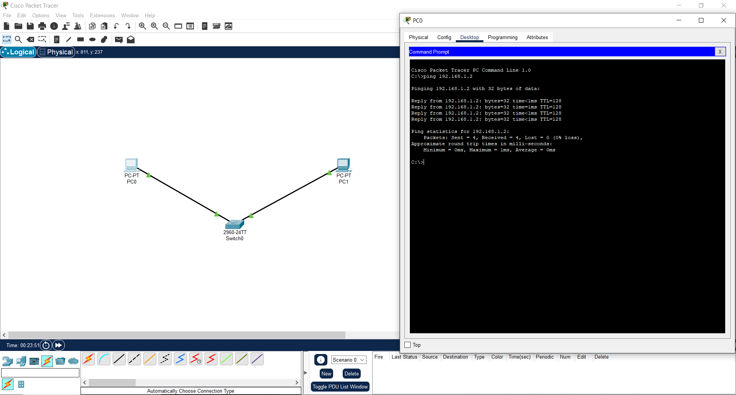

# Lab 2: Basic Router Setup (Connect Two LANs)

🎯 Goal: Connect two LANs using a router to simulate inter-network communication.

🛠 Steps:

* - Use 2 PCs, 2 Switches, and 1 Router.
* - Connect:  
   - PC1 → Switch1 → Router (G0/0)  
   - PC2 → Switch2 → Router (G0/1)
* - Configure IPs:  
   - PC1: 192.168.1.10, Gateway: 192.168.1.1  
   - PC2: 192.168.2.10, Gateway: 192.168.2.1
* - Router Configuration (CLI):
* - interface g0/0  
   ip address 192.168.1.1 255.255.255.0  
   no shutdown
* - interface g0/1  
   ip address 192.168.2.1 255.255.255.0  
   no shutdown
* - From PC1, ping 192.168.2.10  
  Expected: Ping should succeed.

**Output:**

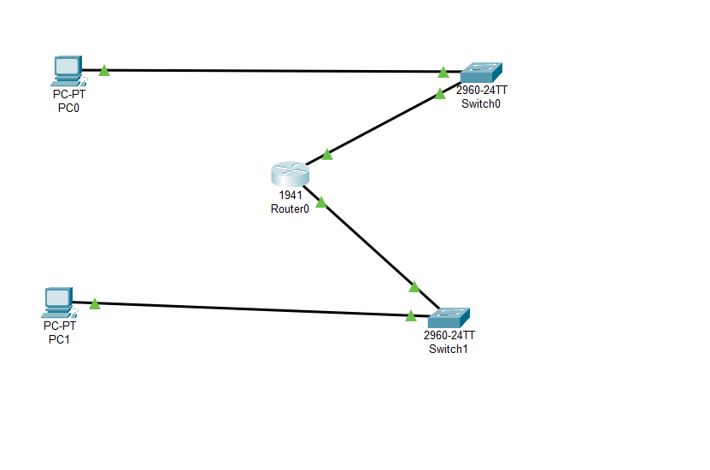

# Lab 3: DNS Request Simulation

🎯 Goal: Simulate DNS resolution using a server and PC.

🛠 Steps:

* - Use 1 PC, 1 Server, and 1 Switch.
* - Assign IPs:  
   - Server: 192.168.3.1  
   - PC: 192.168.3.10, DNS: 192.168.3.1
* - On Server > Services > DNS:  
   - Add: Name = google.com, IP = 8.8.8.8
* - On PC > Command Prompt, run: nslookup google.com
* - Expected: Should return IP address 8.8.8.8.

**Output:**

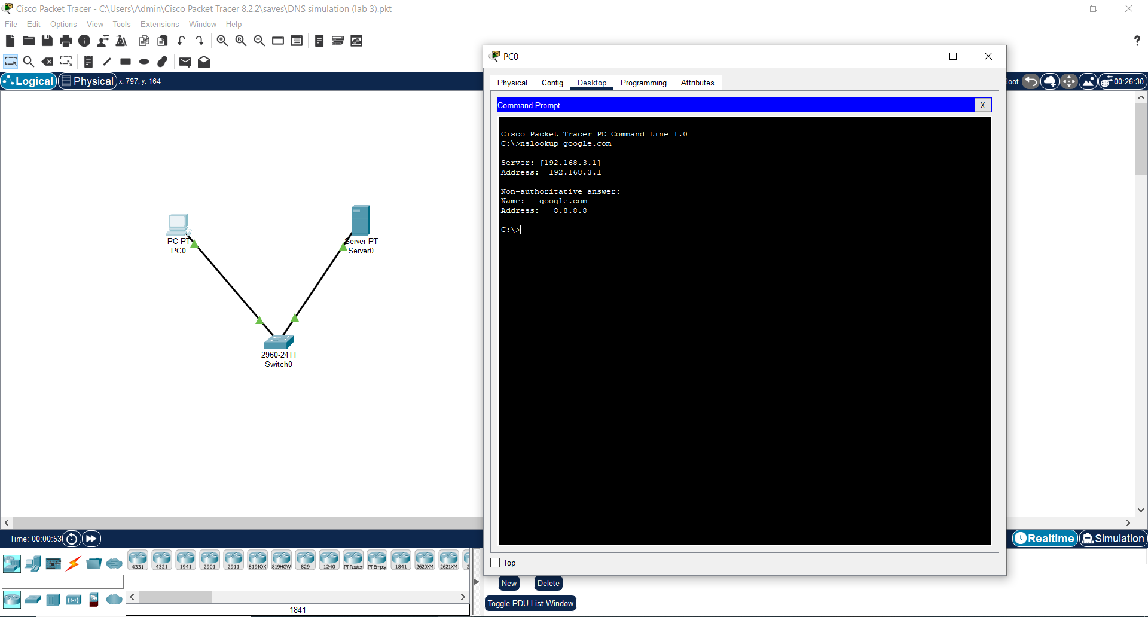

# Lab 4: DHCP Server Lab

🎯 Goal: Automatically assign IP to a PC using DHCP.

🛠 Steps:

* - Use 1 PC, 1 Server, and 1 Switch.
* - Server > Services > DHCP:  
   Pool Name: Office  
   Default Gateway: 192.168.5.1  
   Subnet: 255.255.255.0  
   Starting IP: 192.168.5.10
* - Set PC to DHCP mode from IP Configuration.
* - Expected: PC receives IP automatically (e.g., 192.168.5.10).

**Output:**

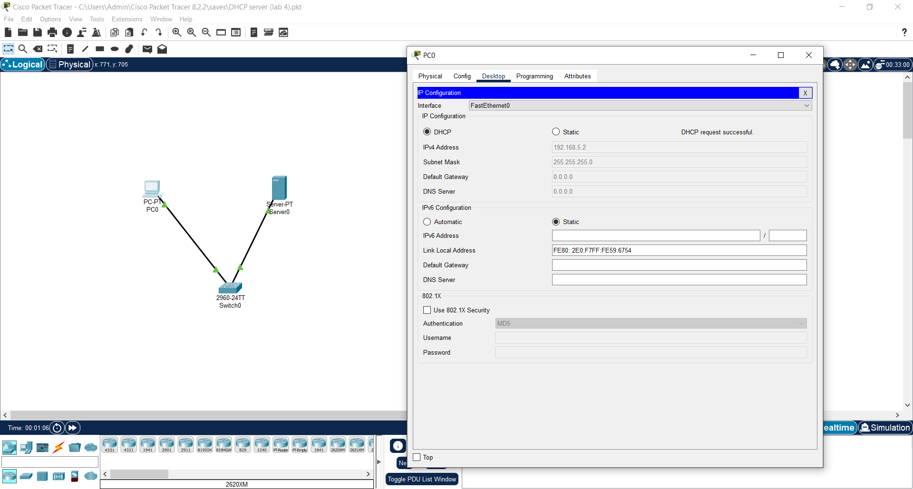

# Lab 5: NAT Configuration

🎯 Goal: Use NAT to let private IP devices access a public server.

🛠 Steps:

* - Use 1 Router, 1 PC (private), 1 Server (public).
* - IP Plan:  
   - PC: 192.168.10.10, Gateway: 192.168.10.1  
   - Router G0/0: 192.168.10.1 (inside)  
   - Router G0/1: 203.0.113.1 (outside)  
   - Server: 203.0.113.5
* - Router Configuration (CLI):
* - interface g0/0  
   ip address 192.168.10.1 255.255.255.0  
   ip nat inside  
   no shutdown
* - interface g0/1  
   ip address 203.0.113.1 255.255.255.0  
   ip nat outside  
   no shutdown
* - access-list 1 permit 192.168.10.0 0.0.0.255
* - ip nat inside source list 1 interface g0/1 overload
* - From PC, ping 203.0.113.5  
  Expected: Ping should succeed via NAT.

**Output:**  
  
  
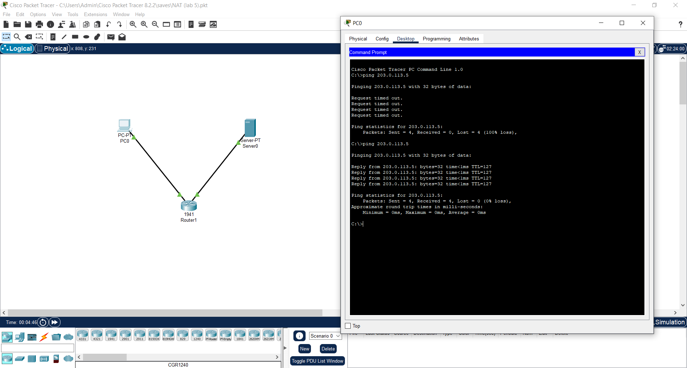

**🧪 Lab 1: Simple LAN Setup**

**🎯 Objective**

To build a Local Area Network (LAN) by connecting two PCs through a switch and verify their connectivity using the ping command.

**🛠️ Devices Used**

| **Device Type** | **Model** | **Quantity** |
| --- | --- | --- |
| End Device | PC (PC-PT) | 2 |
| Switch | 2960 | 1 |
| Cable | Copper Straight-Through | 2 |

**🔗 Network Topology**

PC0 ----

|__Switch0__

PC1 ----

**⚙️ IP Address Configuration**

| **Device** | **IP Address** | **Subnet Mask** |
| --- | --- | --- |
| PC0 | 192.168.1.1 | 255.255.255.0 |
| PC1 | 192.168.1.2 | 255.255.255.0 |

No gateway is required since both PCs are in the same subnet.

**🧭 Step-by-Step Procedure**

**Open Cisco Packet Tracer**

Launch the application.

**Add Devices**

Drag **2 PCs** and **1 Switch** into the workspace.

**Connect Devices**

Use **Copper Straight-Through** cables to connect:

PC0 → Switch (FastEthernet0/1)

PC1 → Switch (FastEthernet0/2)

**Assign IP Addresses**

Click on each PC → Desktop → IP Configuration:

PC0: IP 192.168.1.1, Subnet 255.255.255.0

PC1: IP 192.168.1.2, Subnet 255.255.255.0

**Verify Connectivity**

Open PC0 → Command Prompt

Type: ping 192.168.1.2

**✅ Expected Output**

Reply from 192.168.1.2: bytes=32 time<1ms TTL=128

**Success**: Indicates both PCs can communicate over the LAN.

**📘 Learning Outcomes**

Understand basic LAN setup using switch and PCs

Learn cable types (straight-through)

Practice IP addressing

Use ping for testing connectivity

